**MINOR PROJECT-01**

INTERNET OF THINGS AND ROBOTICS

CUSTOMER SATISFACTION

DESIGNER SCREEN

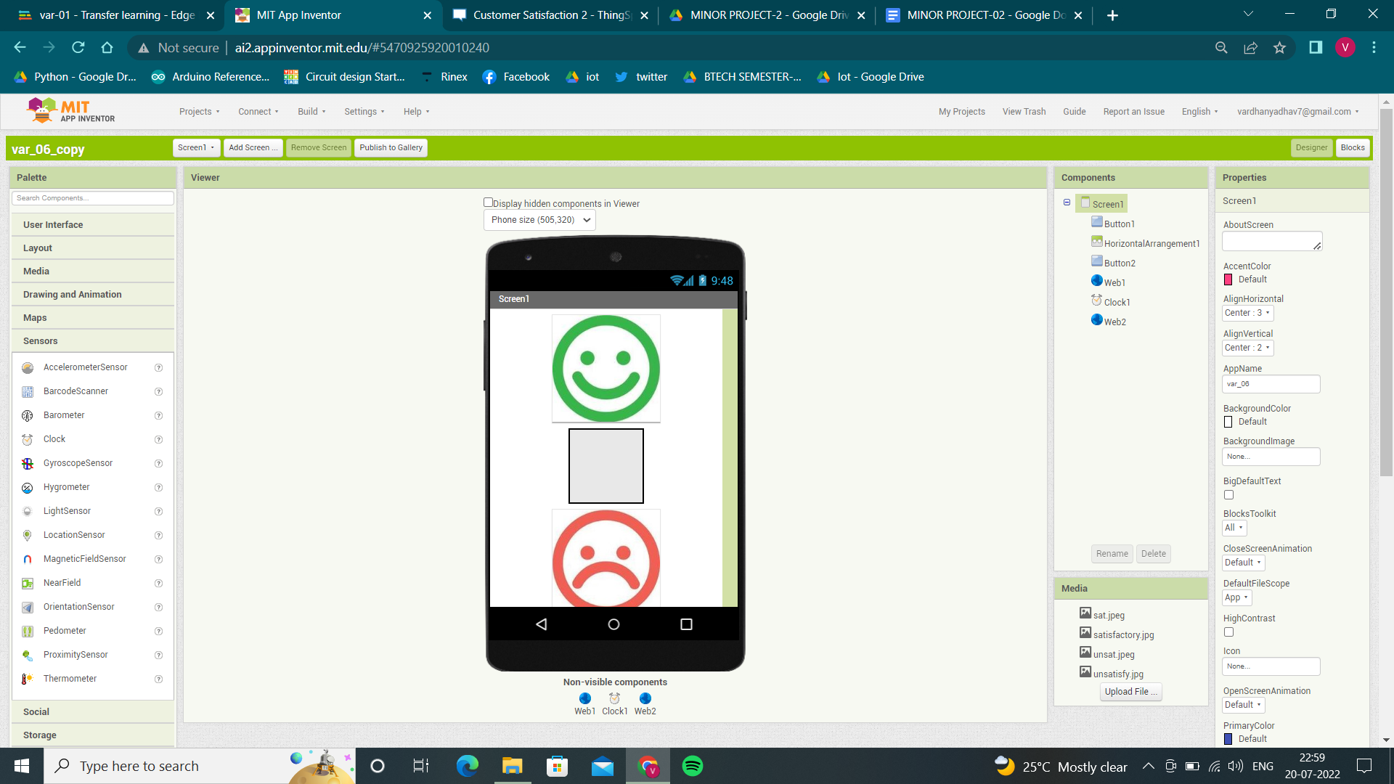

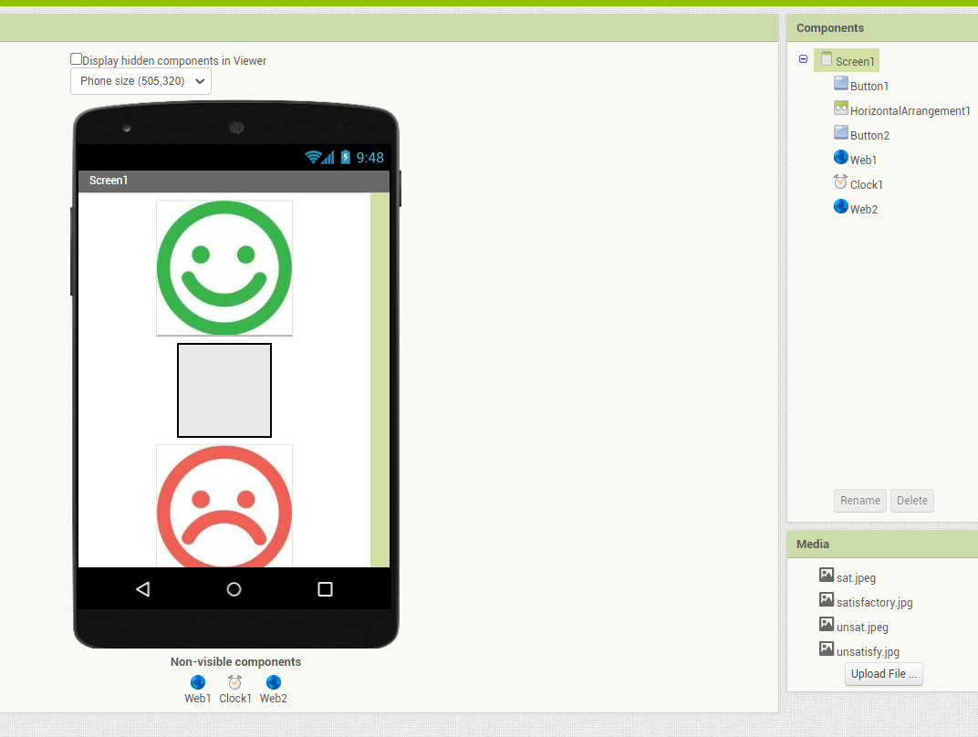

BLOCK SCRREN

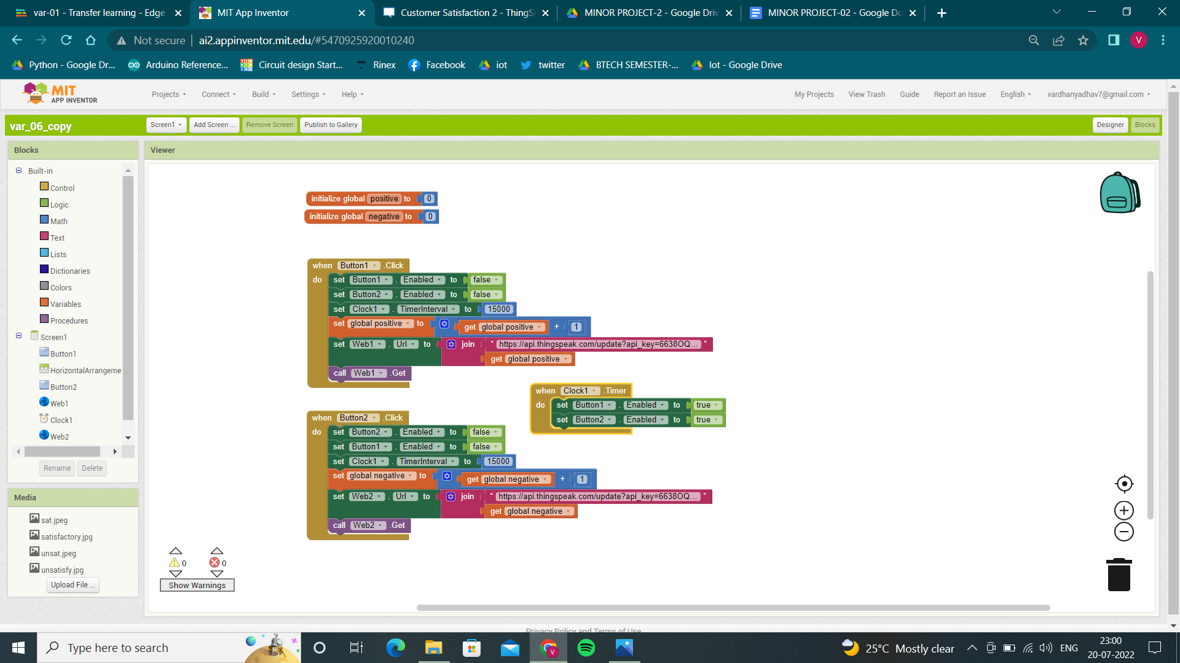

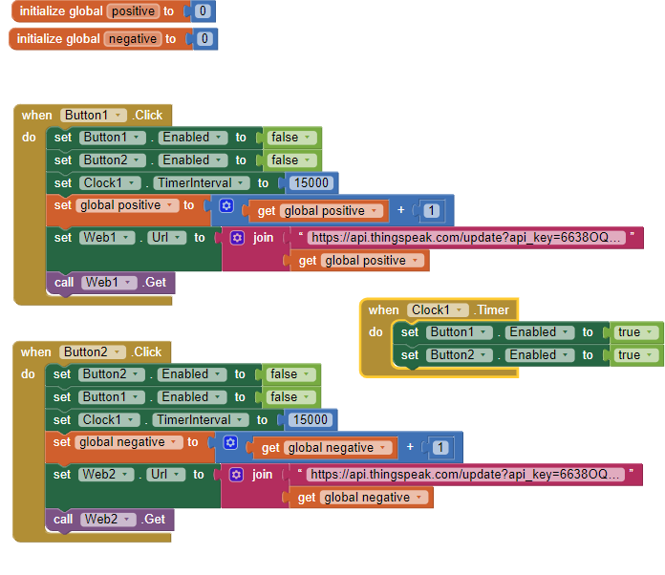

THINGSPEAK

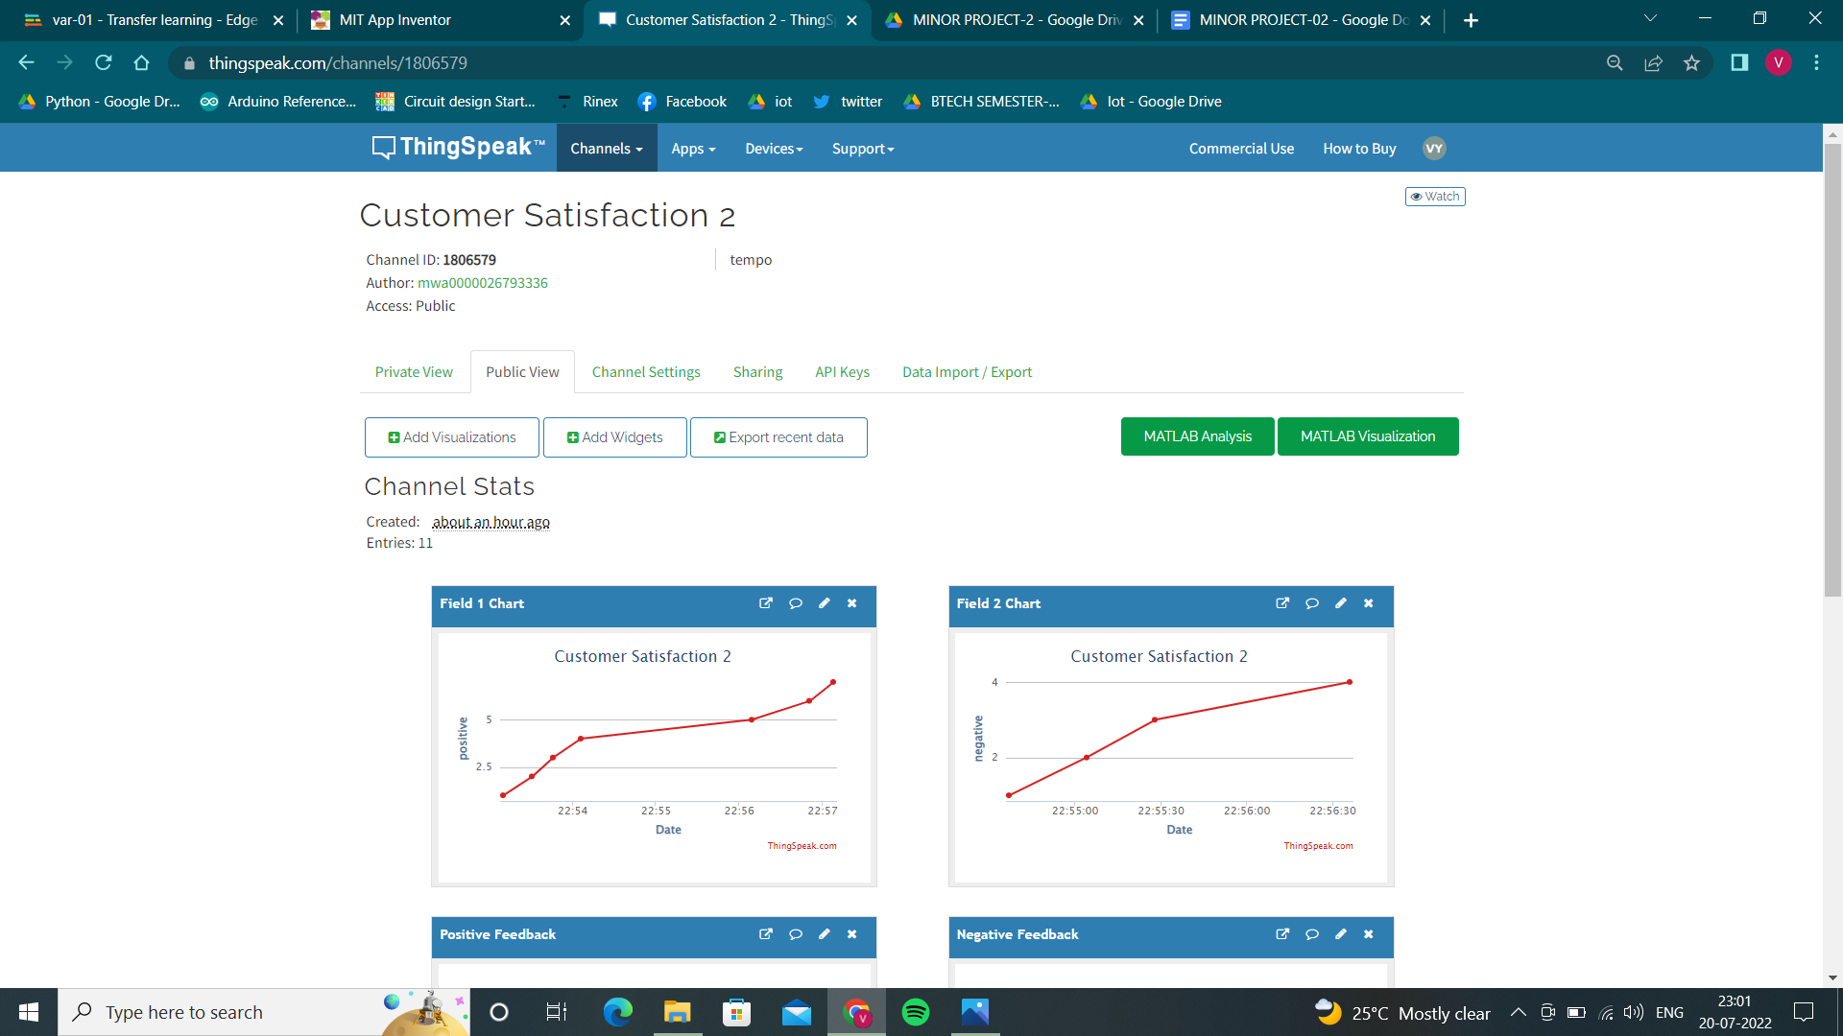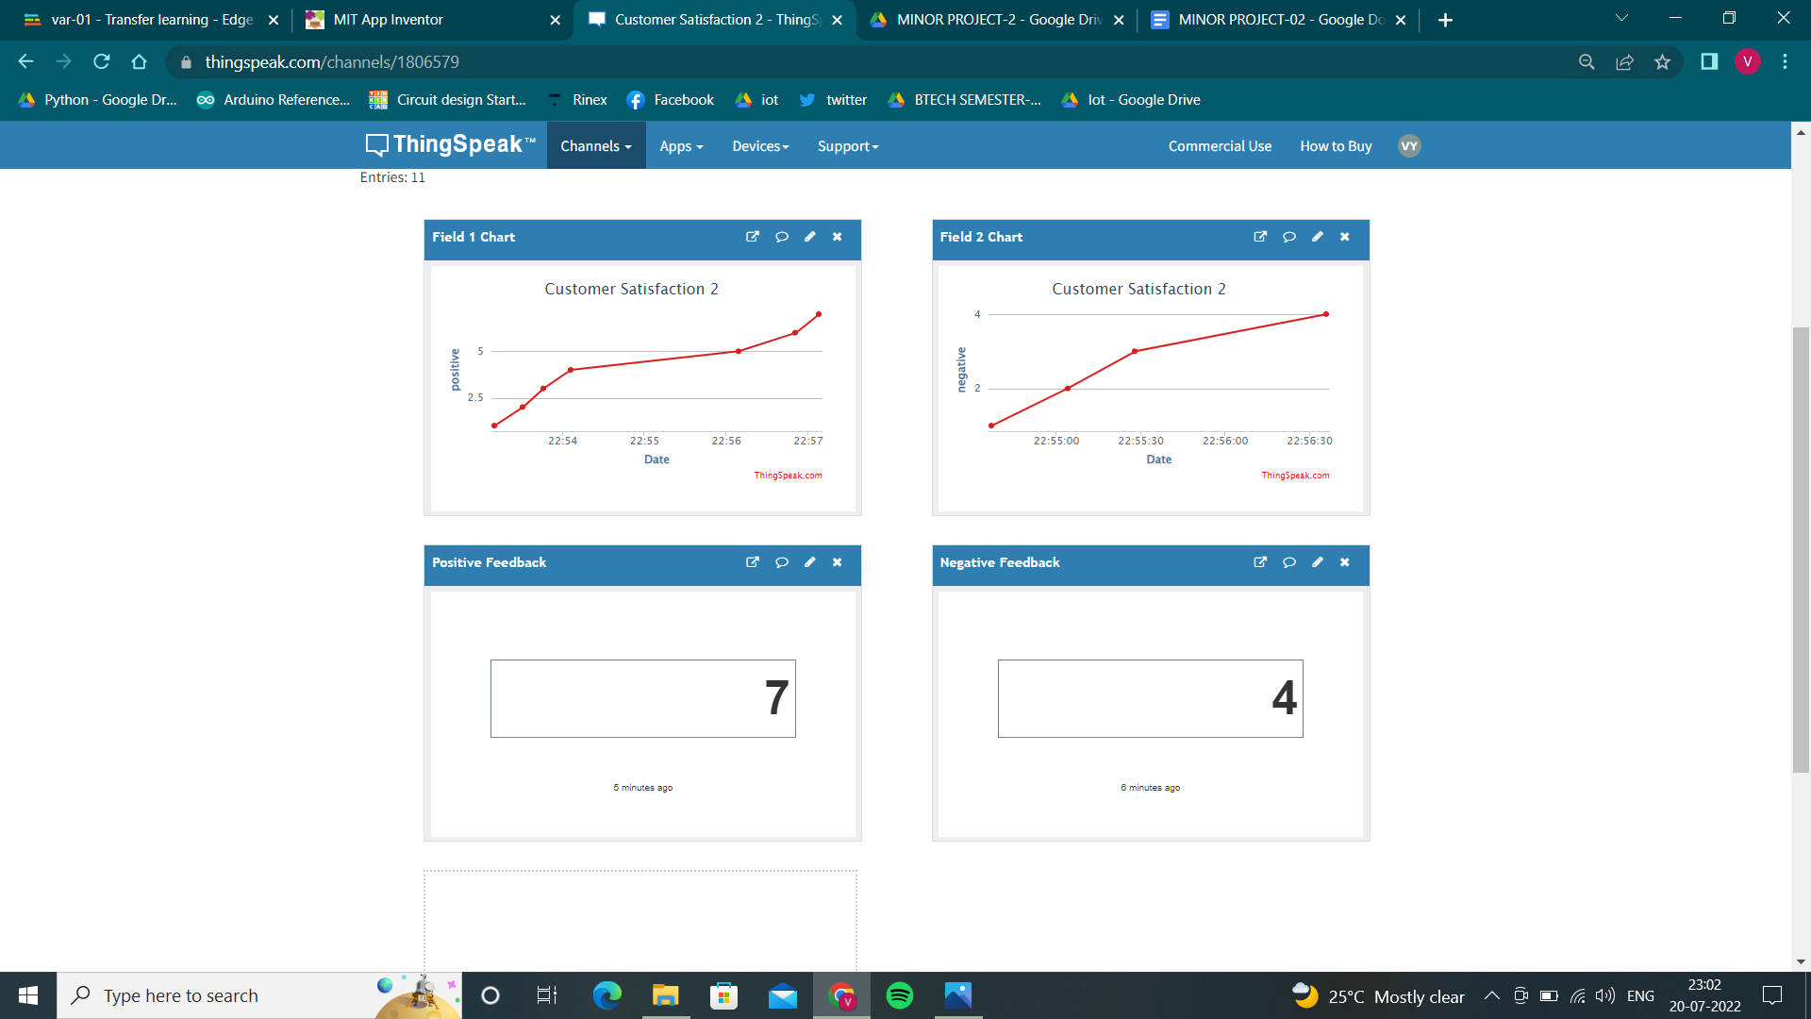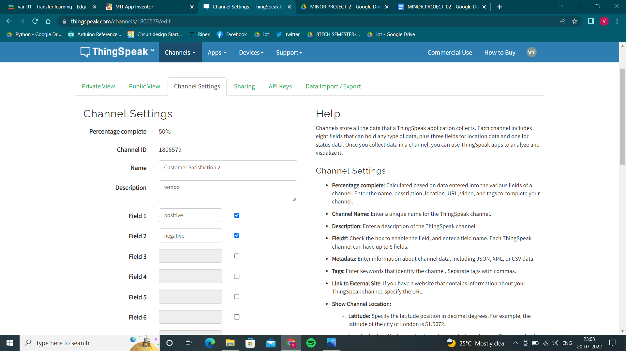

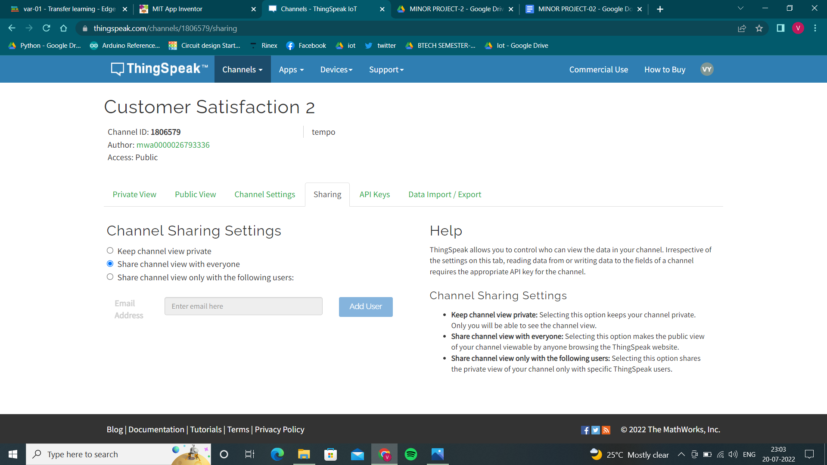

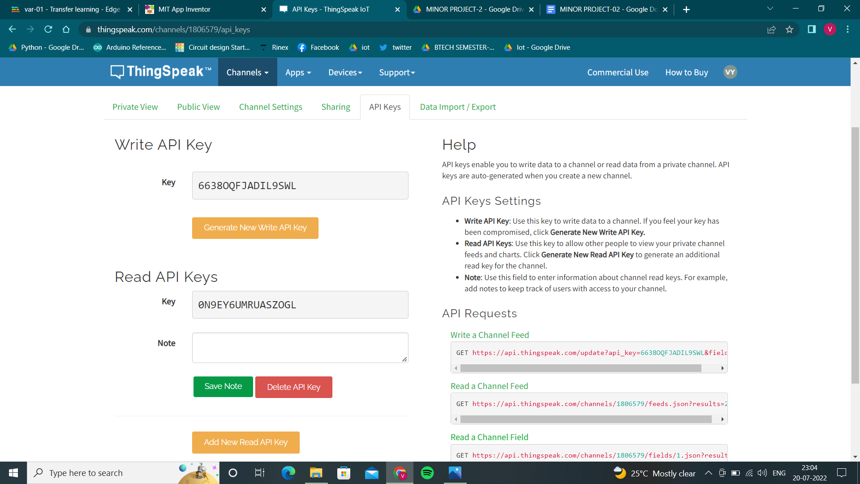

APP INTERFACE

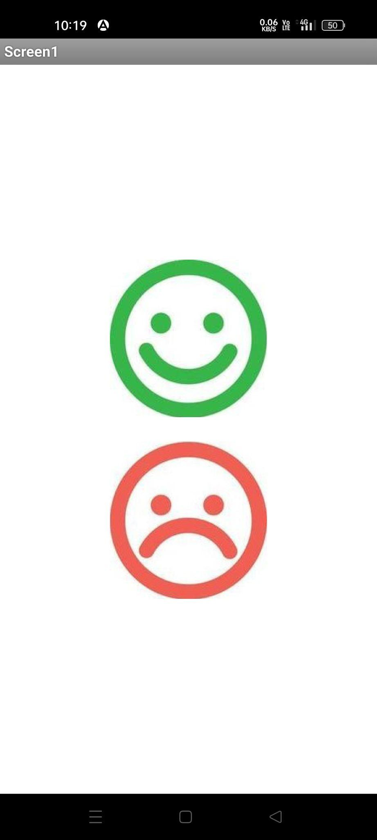

PUBLIC LINK FOR APP:- <https://drive.google.com/file/d/1WgmILmTUqJmEhHk4RXgdilm07gxSY5jp/view?usp=sharing>

FOR APK FILE CHECK IN GIVEN DRIVE

Positive feedback graph : <https://thingspeak.com/channels/1806579/charts/1?bgcolor=%23ffffff&color=%23d62020&dynamic=true&results=60&type=line&update=15>

Positive feedback widget:

<https://thingspeak.com/channels/1806579/widgets/497393>

Negative feedback graph:

<https://thingspeak.com/channels/1806579/charts/2?bgcolor=%23ffffff&color=%23d62020&dynamic=true&results=60&type=line&update=15>

Negative feedback widget:

<https://thingspeak.com/channels/1806579/widgets/497394>

**Steps to create Project:**

Step-1: Create a Thinspeak account and create a new channel in it with two fields one as positive and other as negative.

Step-2: Make channel Public and create two numerical widgets for two fields in pubic view.

Step-3: Make a new project in MIT app inventor.

Step-4: In designer screen add 2 buttons separate them with layout , 2 web’s from connectivity, 1 clock from sensors.Make buttons as emojis.

Step-5: In blocks screen make blocks as follows



Step-6: Connect it with your mobile phone using AI companion and test for values.

Step-7: You can see your output in THINGSPEAK public view.

Step-8: Now download the final app as apk file in Build.

And finally your customer satisfactory app is ready and only you and people with channel links can view the output.